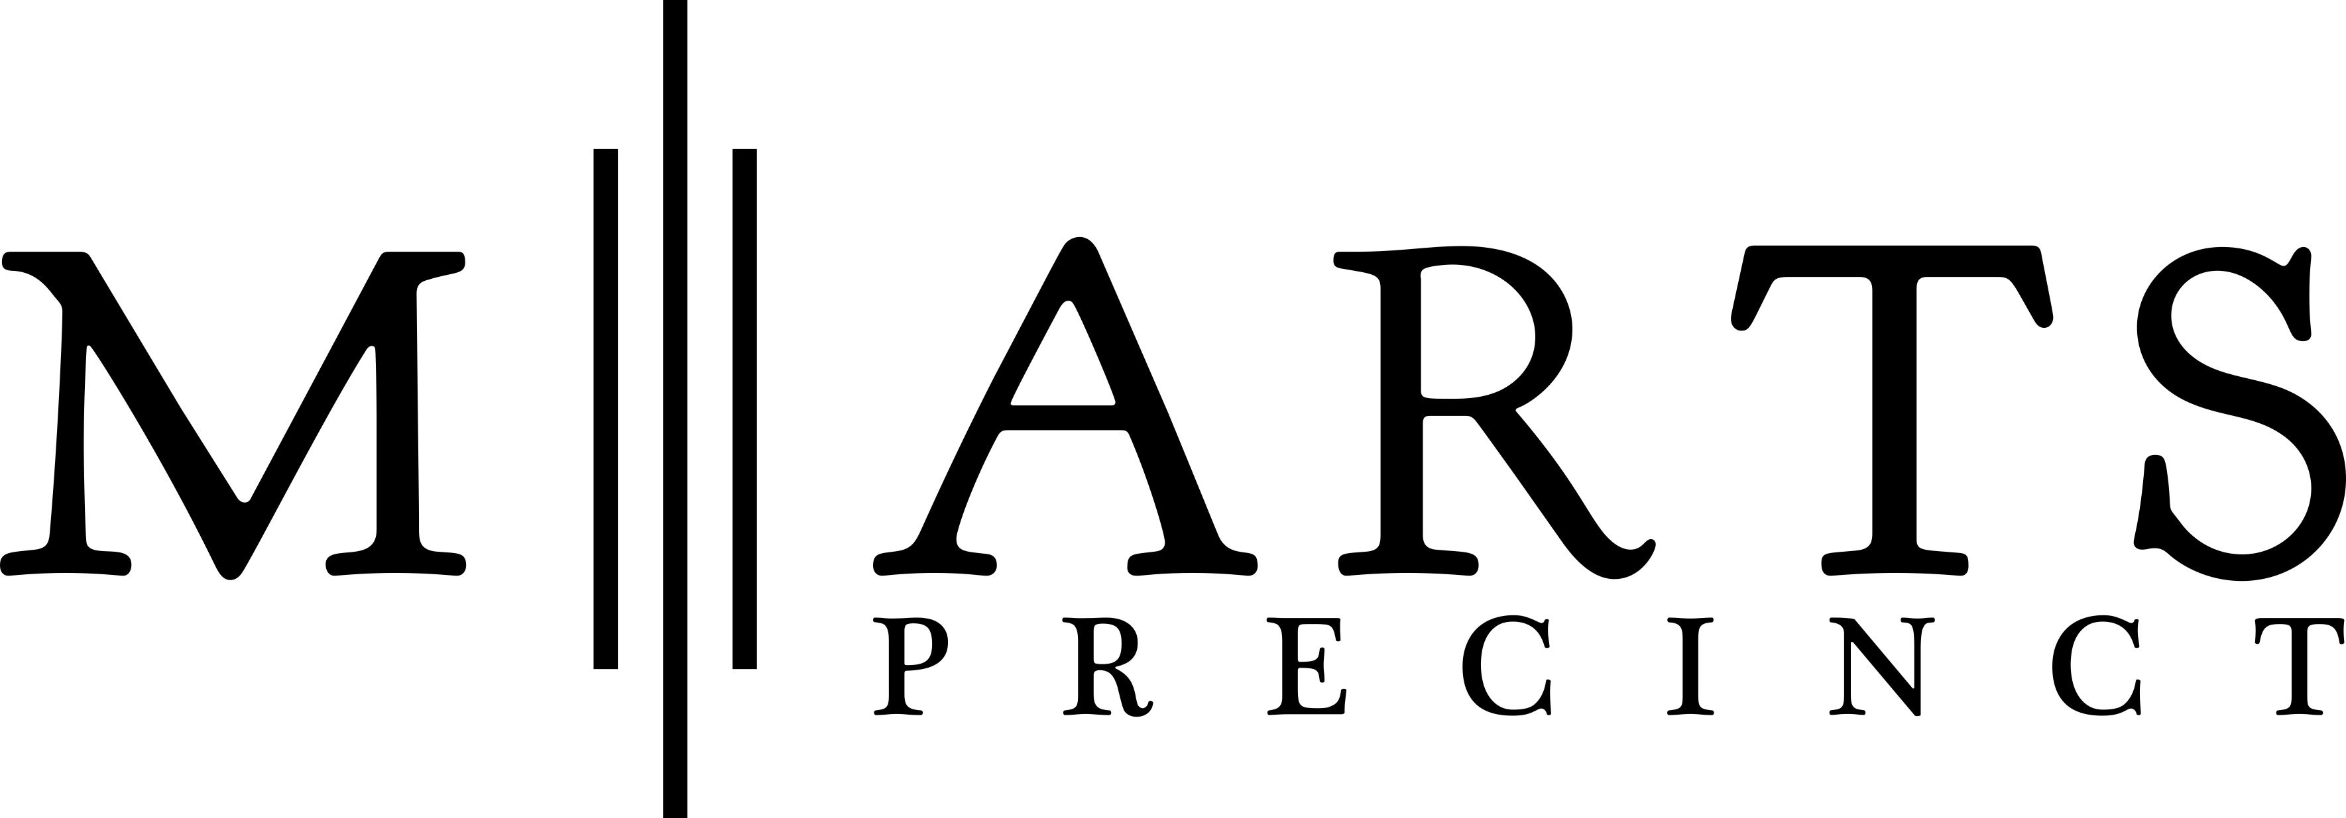
Date: …………………..

STUDIO APPLICATION FORM:

Full Name:

Address:

Phone number:

Email address:

PART 1 - APPLICANT DETAILS:

Along with your completed form, please attach relevant supporting details or documents such as:

A current CV

Some examples of work in JPEG format, ideally 5 or less and under 6 MG in total

Any links to website/blogs/articles

PART 2 - CREATIVE PRACTICE

Please describe your creative practice and how you intend to use the property to produce work. What are your studio requirements?

PART 3 – COMMERCIAL MATTERS

What lease term would you like and when would you be available to move in?

Do you prefer to be in a studio which is (a) open to the public/buyers; (b) has privacy from the public; and/or (c) has privacy from the public but is shared with other artists.

PART 4 – SOME BORING STUFF

Please provide the following:

1) A short description of the proposed environment management plan for waste (if any) your studio will produce.

2) Are there likely to be any health and safety risks arising from your work and, if so, how you will
manage these?

3) A brief outline of any WHS issues that have arisen with your work and how they were
addressed in the past.

PART 5 – HOW DID YOU FIND OUT ABOUT M-ARTS?

SIGNATURE

To the best of my knowledge the statements in this application are true.

Full name:

Signature:

Date:

Please return the complete application form with supporting material to:

Jill Macfie
Creative Director
E: jill@m-arts.com.au
P: 0455 320 920

